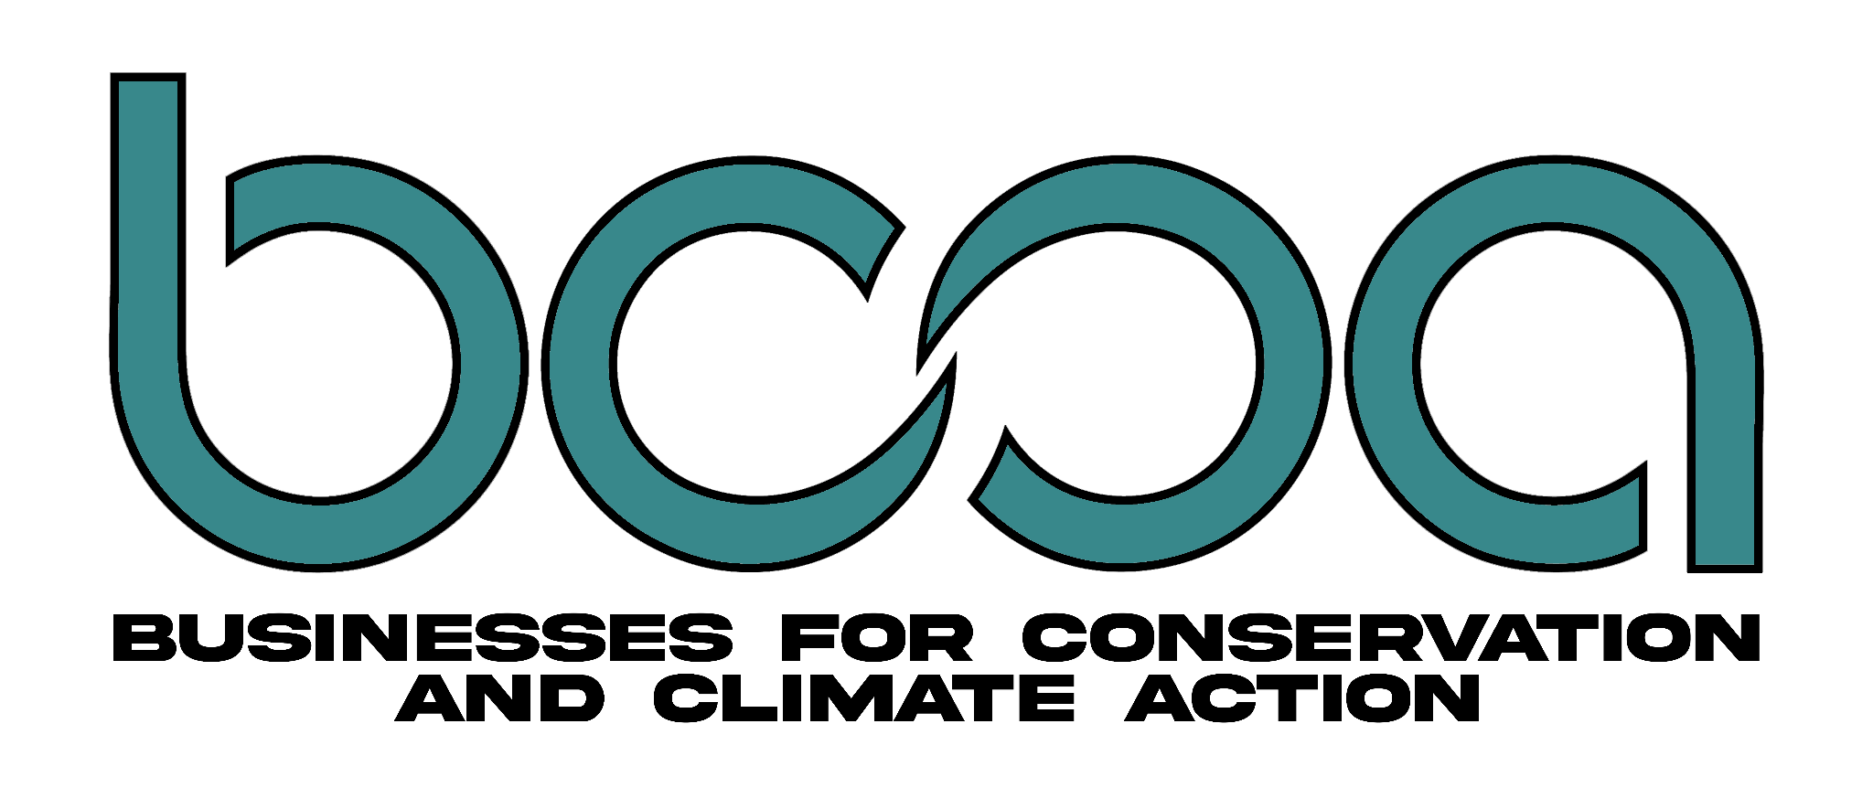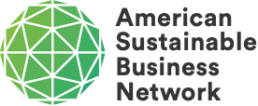

Businesses for Conservation and Climate Action Applaud the Nomination of Proposed National Marine Sanctuary, Alaĝum Kanuux̂ on World Oceans Day

Washington, DC — June 8, 2022 - Businesses for Conservation and Climate Action (BCCA), a coalition of Indigenous-led and community-based businesses, today applauds the National Oceanic and Atmospheric Administration’s (NOAA) announcement that Alaĝum Kanuux̂ is now included in the agency’s list of successful sanctuary nominations.

Alaĝum Kanuux̂, meaning Heart of the Ocean, is a proposed national marine sanctuary in Alaska’s Bering Sea. The designation of Alaĝum Kanuux̂ would establish the first marine sanctuary off the coast of Alaska.

“Indigenous people of this continent have successfully managed large seascapes and marine resource dependent economies for thousands of years,” said Marissa Merculieff, Director of the Office of Justice and Governance Administration at the Aleut Community of St. Paul Island Tribal Government (ACSPI). “When our communities and businesses are provided a genuine role in policy making, we can expect to see meaningful results that mirror this legacy for the good of all communities. This new approach to National Marine Sanctuaries is the path our tribe has chosen to deliver a viable future on our own terms, and it’s a major precedent for Indigenous communities throughout the country.”

If NOAA proceeds with the designation process, Alaĝum Kanuux̂ would also become the first marine sanctuary established on the basis of government-to-government co-management between the United States and a federally recognized tribe.

“The tribe’s approach to sustainable business opportunities, equitable Indigenous leadership, and visionary new approaches to conservation make Alaĝum Kanuux̂ truly groundbreaking,” said David Levine, President and Co-founder at American Sustainable Business Network (ASBN). “This is a tremendous way to celebrate World Oceans Day. This is an opportunity, with national implications, for the establishment of Indigenous-led governance and a seat at the table for all business interests who depend on the conservation of this magnificent seascape for their wellbeing and livelihoods. BCCA and ASBN urge a swift pivot towards the designation of this amazing proposal as a national marine sanctuary. There isn’t a moment to lose.”

Nominated by ACSPI, a BCCA founding member, the Alaĝum Kanuux̂ proposal has received rigorous technical review and is now positioned for designation. Through the National Marine Sanctuaries Act, NOAA has the authority to identify, designate and protect areas of the marine environment with special national significance.

“I am thrilled that the St. Paul Tribal Government and NOAA are together advancing this visionary nomination in support of Alaska fishing businesses and their critical island ecosystem,” said Linda Behnken, commercial fisherman and Executive Director of the Alaska Longline Fishermen’s Association. “We’ve known for decades that family fishing businesses need healthy ecosystems to survive. But to address the climate threats of tomorrow, businesses, tribes, and the government need to come together to advance grounded and groundbreaking conservation actions, as the Biden Administration has recognized in the America the Beautiful program. This sanctuary nomination truly sets the conservation bar, and I’m proud to stand in strong support of it alongside so many tribal fishing businesses across Alaska.”

About BCCA
Businesses for Conservation and Climate Action is a coalition of Indigenous-led and community-based businesses, organized to develop and deliver grounded and, therefore, durable conservation policy wins for the benefit of all. Our alliance is formed around the collective vision that solutions between humans and nature are rooted in rediscovering our place within the global environment and having the humility and ambition to embrace this role. Our mission is to establish national policies that recognize sustainable small businesses as compatible with healthy lands and oceans, and to enhance rather than exclude these sustainable businesses from conversations about resource access at every step of the decision-making process. Our work is guided by a firm commitment to social equity, local and traditional wisdom, and triple bottom line solutions that restore social, ecological and economic health.

About ASBN
The American Sustainable Business Network partners with business organizations and companies to advocate for solutions and policies that support an equitable, sustainable stakeholder economy. ASBN is a multi-issue, business organization advocating on behalf of all sectors, sizes, and geographies of industry. ASBN and its association members collectively represent over 250,000 businesses across our networks. ASBN is coalition-focused in our approach to solving the pervasive and systemic issues of climate and energy, infrastructure, circular economy, and creating an inclusive just stakeholder economy. ASBN is changing the rules by which business is done so it is better for all people and the environment.

Media Contacts:
Noah Oppenheim
National Policy Coordinator, BCCA
noah@homarus.co

Linda Behnken
Executive Director, Alaska Longline Fishermen’s Association
alfafish@gmail.com

